Inrtduction:

**The most accurate, diversified, and cost-effective Oracle on Fantom Network**

Miracle is an open-source & fully decentralized oracle that build a cross-chain oracle on Fantom Network with On-chain data validation.

Mission:

A lack of a decentralized price aggregator and the need of trustable and scalable data feeds for DeFi applications has motivated us to develop a platform that provides all necessary prices of cryptocurrencies to the DeFi world. Moreover, with advanced technologies, our users are granted all security concerns and feel secure that the data they are using is trustworthy and valid.

Why do blockchains need oracles?

Blockchains are great at providing immutable storage and deterministic verifiable computations. However, they cannot access trusted real-world information available outside their networks. Band Protocol enhances smart contract functionalities by granting access to reliable data without any central authority or points of failure.

Why fantom: scalability, Security, Speed, Cost, EVM-Compatible

Cost — The cost of sending a transaction on Fantom is extremely cheap

Security — The Proof-of-Stake network of Fantom’s validator nodes secures the network in a leaderless, decentralized, and trustless way.

Speed — Fantom’s Lachesis consensus mechanism can facilitate thousands of transactions per second whilst maintaining reliability and security.

Scalability — Already, Fantom can facilitate several thousands of transactions per second. However, the Fantom protocol can seamlessly scale to thousands of nodes, without compromising the privacy or security of the network. The scalability of Fantom allows developers to continuously innovate and build on their applications to a global scale.

EVM-Compatible —Fantom is EVM (Ethereum Virtual Machine) compatible.

Miracle Platform Architecture:

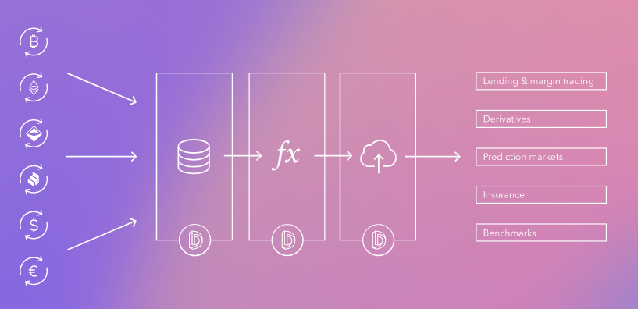

Token Utility:

Governance

Paywall

Reward

Incentive

Purchase data service

Staking

Users gain authorities, interests and eligibility to use services (which services?)

Miracle tokencan be used for data feeding, quering and analytics

Miracle tokens will be used as an incentive to get the community more active in the platform

Miracle token will be used for rewarding in miracle platform (needs more elaboration like why & when)

Miracle token will be used data access behind the paywall (private APIs)

Miracle token holders can vote for the product upgrades and change of parameters

Cross-Chain Interoperability:

Put the logo of them

Feature:

   

- Miracle ensure us to have the actual price of a crypto asset to ensure that no funds get lost and also smart contracts have trusted price answer to work properly.

- Arbitrage serves a broader market ecosystem by bringing prices across different markets into alignment.

- Miracle can assist the users trying to predict the asset prices or other events over a predetermined period of time.

- Miracle gathers information about the deals in NFT market places and brings them together

Roadmap: